Web-Based Attacks Assignment

Introduction
For the cyber security module, we are required to download DVWA on our Kali Linux systems to test for different web-based attacks and test how we might mitigate the attacks previously initiated.

Attacks
The first attack I tested was the SQL Injection attack. To do this I navigated to the SQL Injection tab on DVWA and typed in 1’ UNION SELECT user, passwords FROM users #. This returned me with a list of users and their data stored on the database.
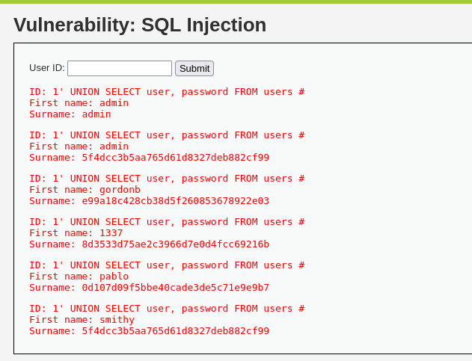
Figure 1 SQL Injection
The second attack I tested was the cross site scripting attack. This attack allowed me to enter a name and message and upload it to the database. I entered the line - <script>alert(‘Stored XSS’)</script> in the message section and hacker in name section to test if this worked. A pop up appeared on screen indicating it was successful.
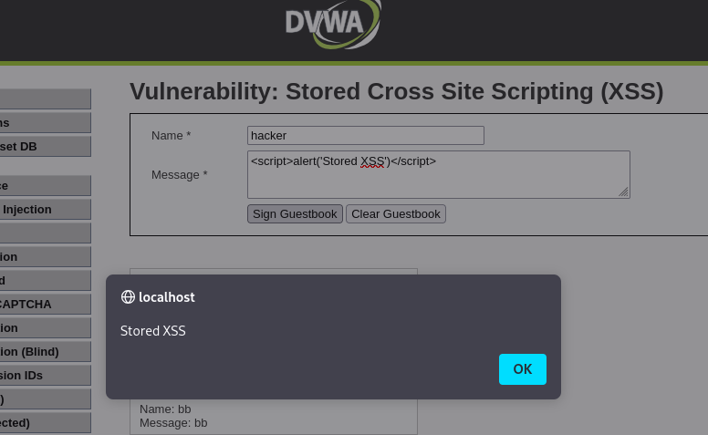
Figure 2 Stored Cross Site Scripting
Next for Reflected Cross Site Scripting I entered <Script>alert(‘Reflected XSS’)</script> into the enter name text field and it displayed a pop up displaying XSS indicating a successful attack.
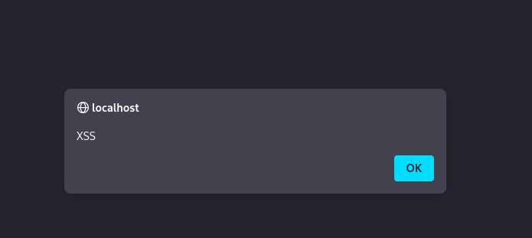
Figure 3 Reflected Cross Site Scripting

Next, I initiated the DOM Based Cross site scripting attack for this I selected the DOM tab and went into the global search bar and entered #<script>alert(‘DOM XSS’)</script>. I pressed enter on this and then I selected English, clicked submimt and this pop up appeared showing that the attack worked.
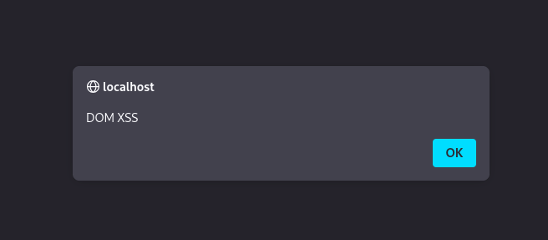
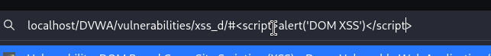
Figure 4 DOM Based Cross Site Scripting
The final attack I tested was the file upload attack. This attack allowed me to upload a php file. To do this I went into the php.ini and set file_upload to true. Then I download the gd library using, ‘apt update’ and then ‘apt intall php-gd’. It then allowed me to upload files to a folder in the database.
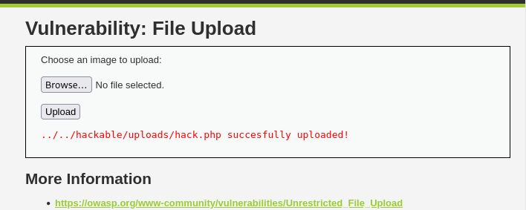
Figure 5 File Upload

Mitigating Attacks
The next section was about trying to prevent the three attacks we performed in the first section – SQL Injection, Cross Site Scripting and File Upload. To do this on DVWA there is a tab called DVWA security. In this tab there is a drop-down menu which allows you to choose your security level. Initially it was set to low to allow the attacks to occur, but I set it to impossible in order to prevent these attacks.
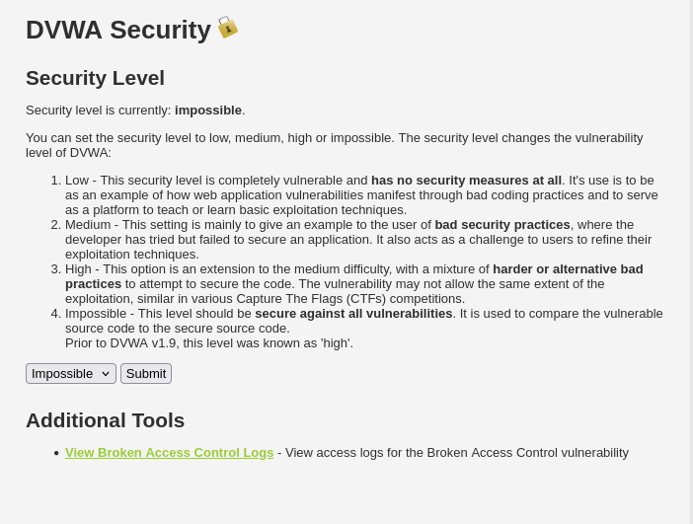
Figure 6 DVWA Security

I had a look at the source code for what the differences were in the low and impossible settings. This is what I came out with the understanding of:

The first files I looked at were the low.php and impossible.php for sql injection.
The differences in these scripts are
Low accepts any input through $_request whereas impossible requires the input to be a number using the is_numeric() and intval() functions.
Low uses string concatenation that allows any insert directly to the sql and impossible uses prepared statements meaning it uses bind parameters to allow for only certain types of input
Low also doesn’t have cross site request forgery (csrf) protection but impossible uses a checkToken() function to prevent csrf.
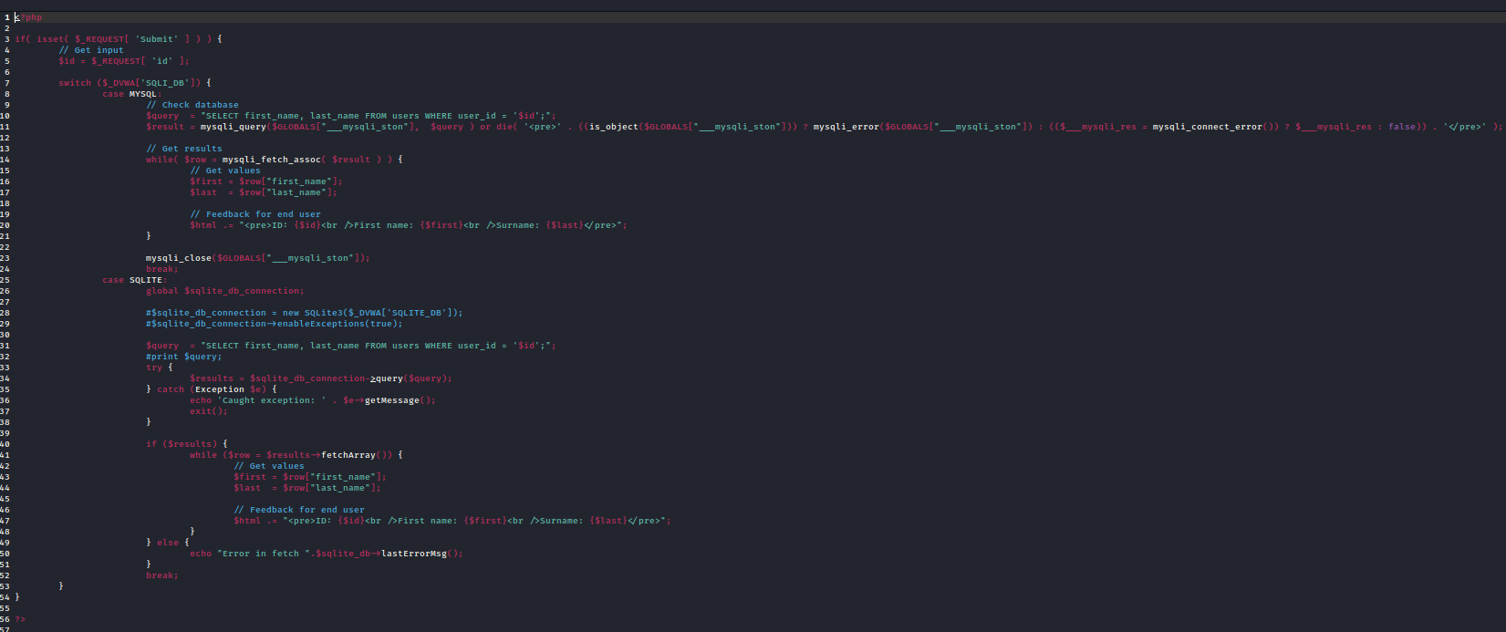
Figure 7 Low setting for SQL Injection
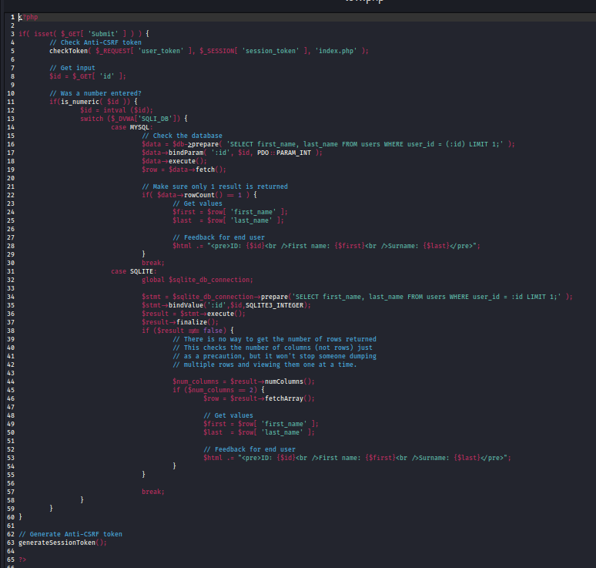
Figure 8 Impossible setting for SQL Injection
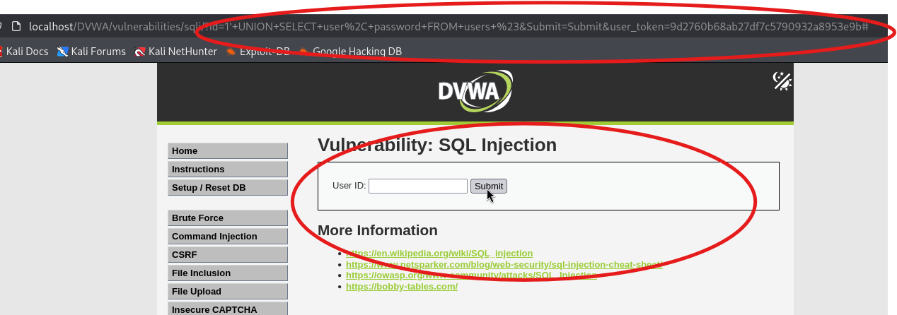
Figure 9 Mitigation for SQL Injection

The next files I looked at were the low.php and impossible.php for Stored Cross Site Scripting.
The differences in these scripts are
That low does not has csrf protection but the impossible file does meaning if the user does not have the correct token they cannot submit any data to the database from here. You can see this in the checkToken() function in the impossible.php
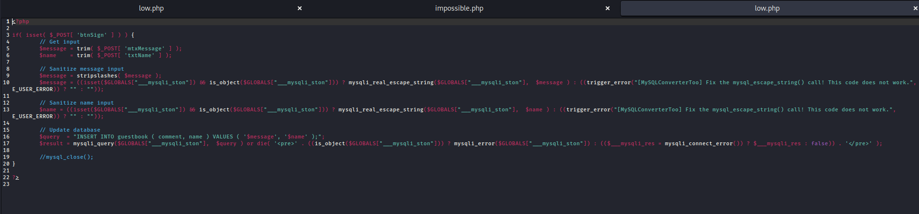
Figure 10 Low setting for Stored Cross Site Scripting
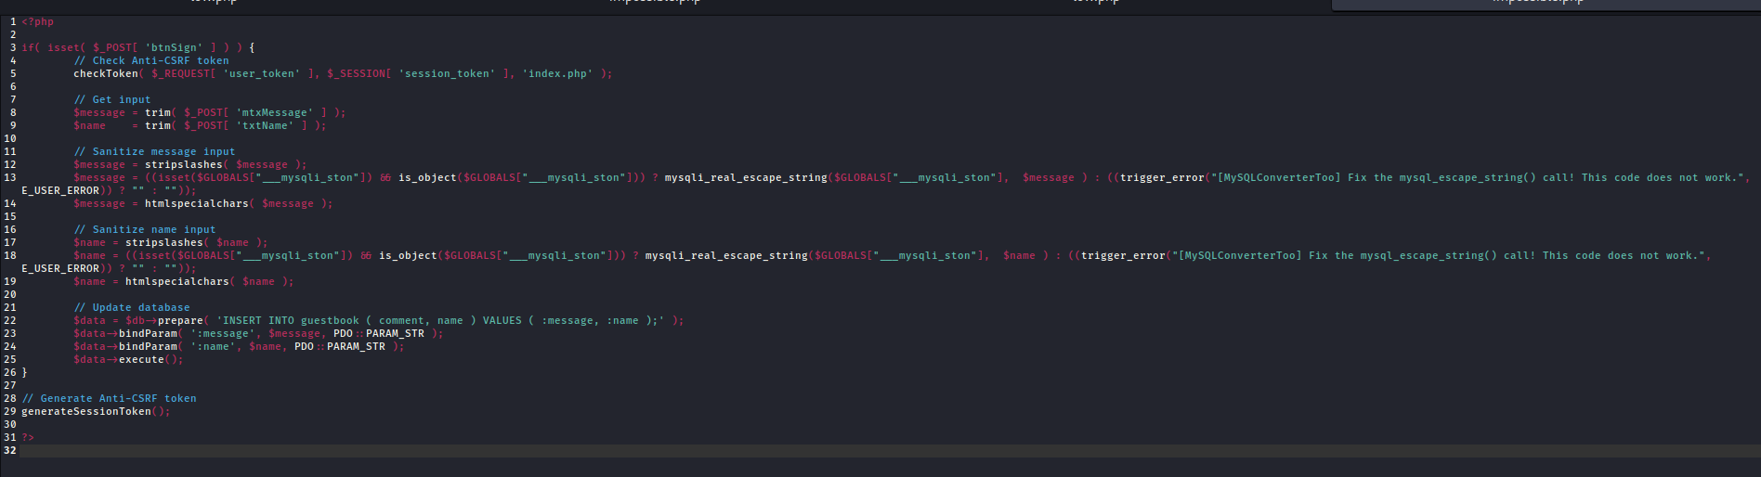
Figure 11 Impossible Setting for Stored Cross Site Scripting
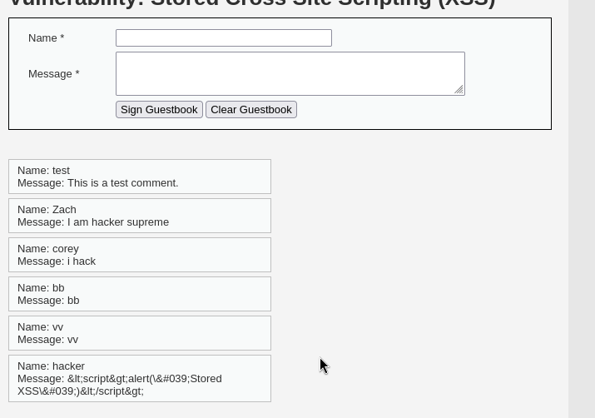
Figure 12 mitigation for stored xss

The next file I looked at was the low.php and impossible.php for Reflected Cross Site Scripting.
The differences in these scripts are
Again the impossible file here implement csrf protection.
The impossible file also converts the characters <>”’& into characters that cant execute any commands in the htmlspecialchars() function.
The impossible also removes the header that disabled xss filters.
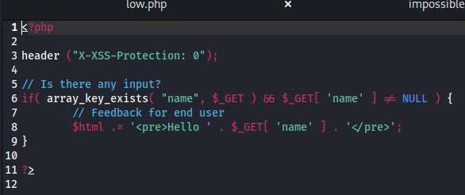
Figure 13 Low Setting for Reflected Cross Site Scripting
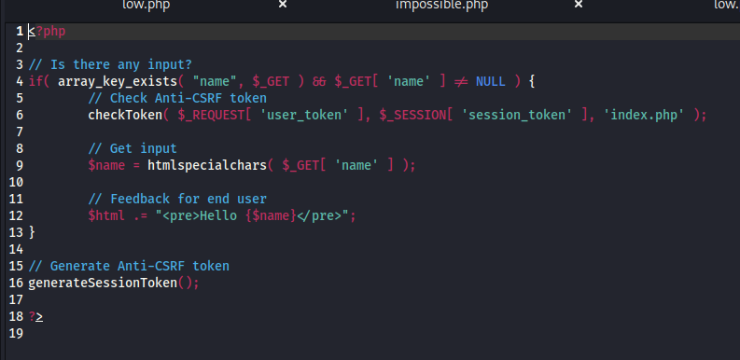
Figure 14 Impossible setting for Reflected Cross Site Scripting
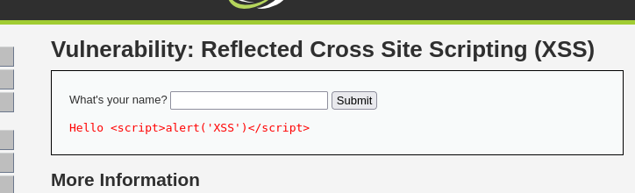
Figure 15 Not Working mitigation

The next file I looked at was the low.php and impossible.php for DOM Based Cross Site Scripting.
The issue is here that it doesn’t have source code to change. It is done somewhere in DVWA’s UI and I was unsuccessful in finding where that was.
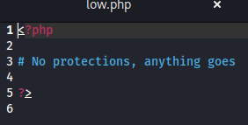
Figure 16 Low setting for DOM Based Cross Site Scripting
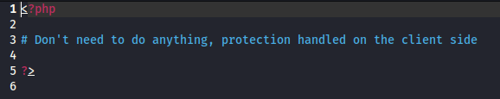
Figure 17 Impossible setting for DOM Based Cross Site Scripting
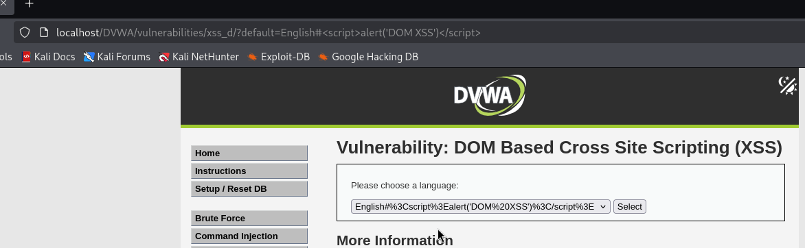
Figure 18 Mitigation for DOM

The next file I looked at was the low.php and impossible.php for File Upload.
The differences in these scripts are
Once again there is no csrf protection in the low.php and impossible has a checkToken() function.
The impossible file has file validation. In the file it checks if the file uploaded is a .jpg or .png it also checks if it is below a size of 100000. This means that the only files allowed to be uploaded are image files beneath a certain size.
The impossible.php also renames files when its uploaded in the $target_file line. This means that the file will be assigned a random string of characters and numbers as the name to prevent the uploaded file from overwriting existing files.
The Impossible file also re encodes the image using imagecreatefromjpg/png this makes sure there are no commands embedded in the image file.
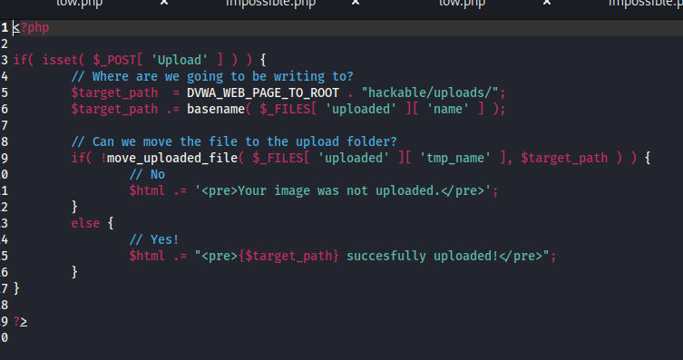
Figure 19 Low Setting for File Upload
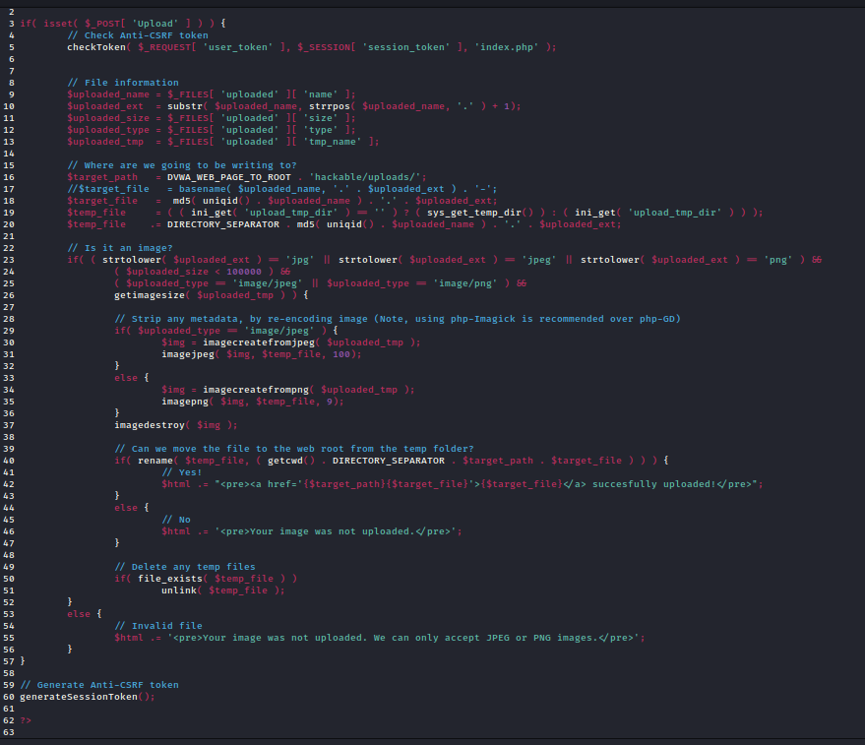
Figure 20 Impossible setting for File Upload
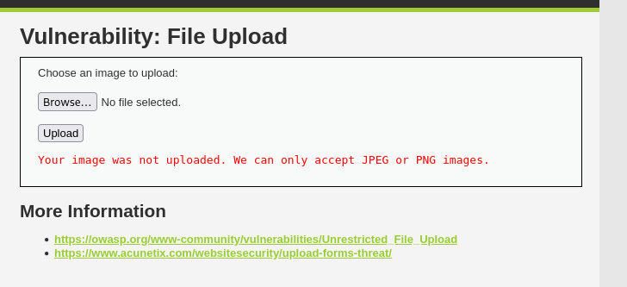
Figure 21 Mitigation for File Upload

Conclusion
In conclusion I learned a lot about setting up the DVWA environment in Kali and how to carry out the three attacks – SQL Injection, Cross site scripting and file upload. I learned about what these attacks do also.
I also learned about how to mitigate these attacks which I feel is an extremely useful skill to have gained in terms of adding to network security. I feel I gained a very good understanding of how each part of the source code for the mitigation works except for the DOM Based Cross Site Scripting which was done on the UI elsewhere.

